3. BIO2 Compliance for Log360

Tagline – Streamline BIO2 compliance monitoring and audit reporting with Log360.

Overview :
The BIO2 Compliance extension for Log360 helps organizations maintain adherence to BIO2 requirements. By integrating this extension, IT and security teams gain complete visibility into their compliance posture and audit trails.
Log360 continuously collects and correlates log data from Active Directory, Windows, Unix/Linux, Microsoft 365, cloud platforms, and network devices, mapping events directly to BIO2 controls. Security teams can track compliance status in real time, investigate incidents quickly, and generate audit-ready reports with a single click.

Key Features:
- Generate comprehensive audit-reports mapped to all BIO2 requirements and controls.
- Offers pre-built and customizable reports for compliance, security, and operational insights with interactive dashboards.
- Analyzes user and entity behavior for insider threats and unusual log patterns across your infrastructure.
- Export reports in PDF and CSV format for auditors, management, or regulatory submissions.



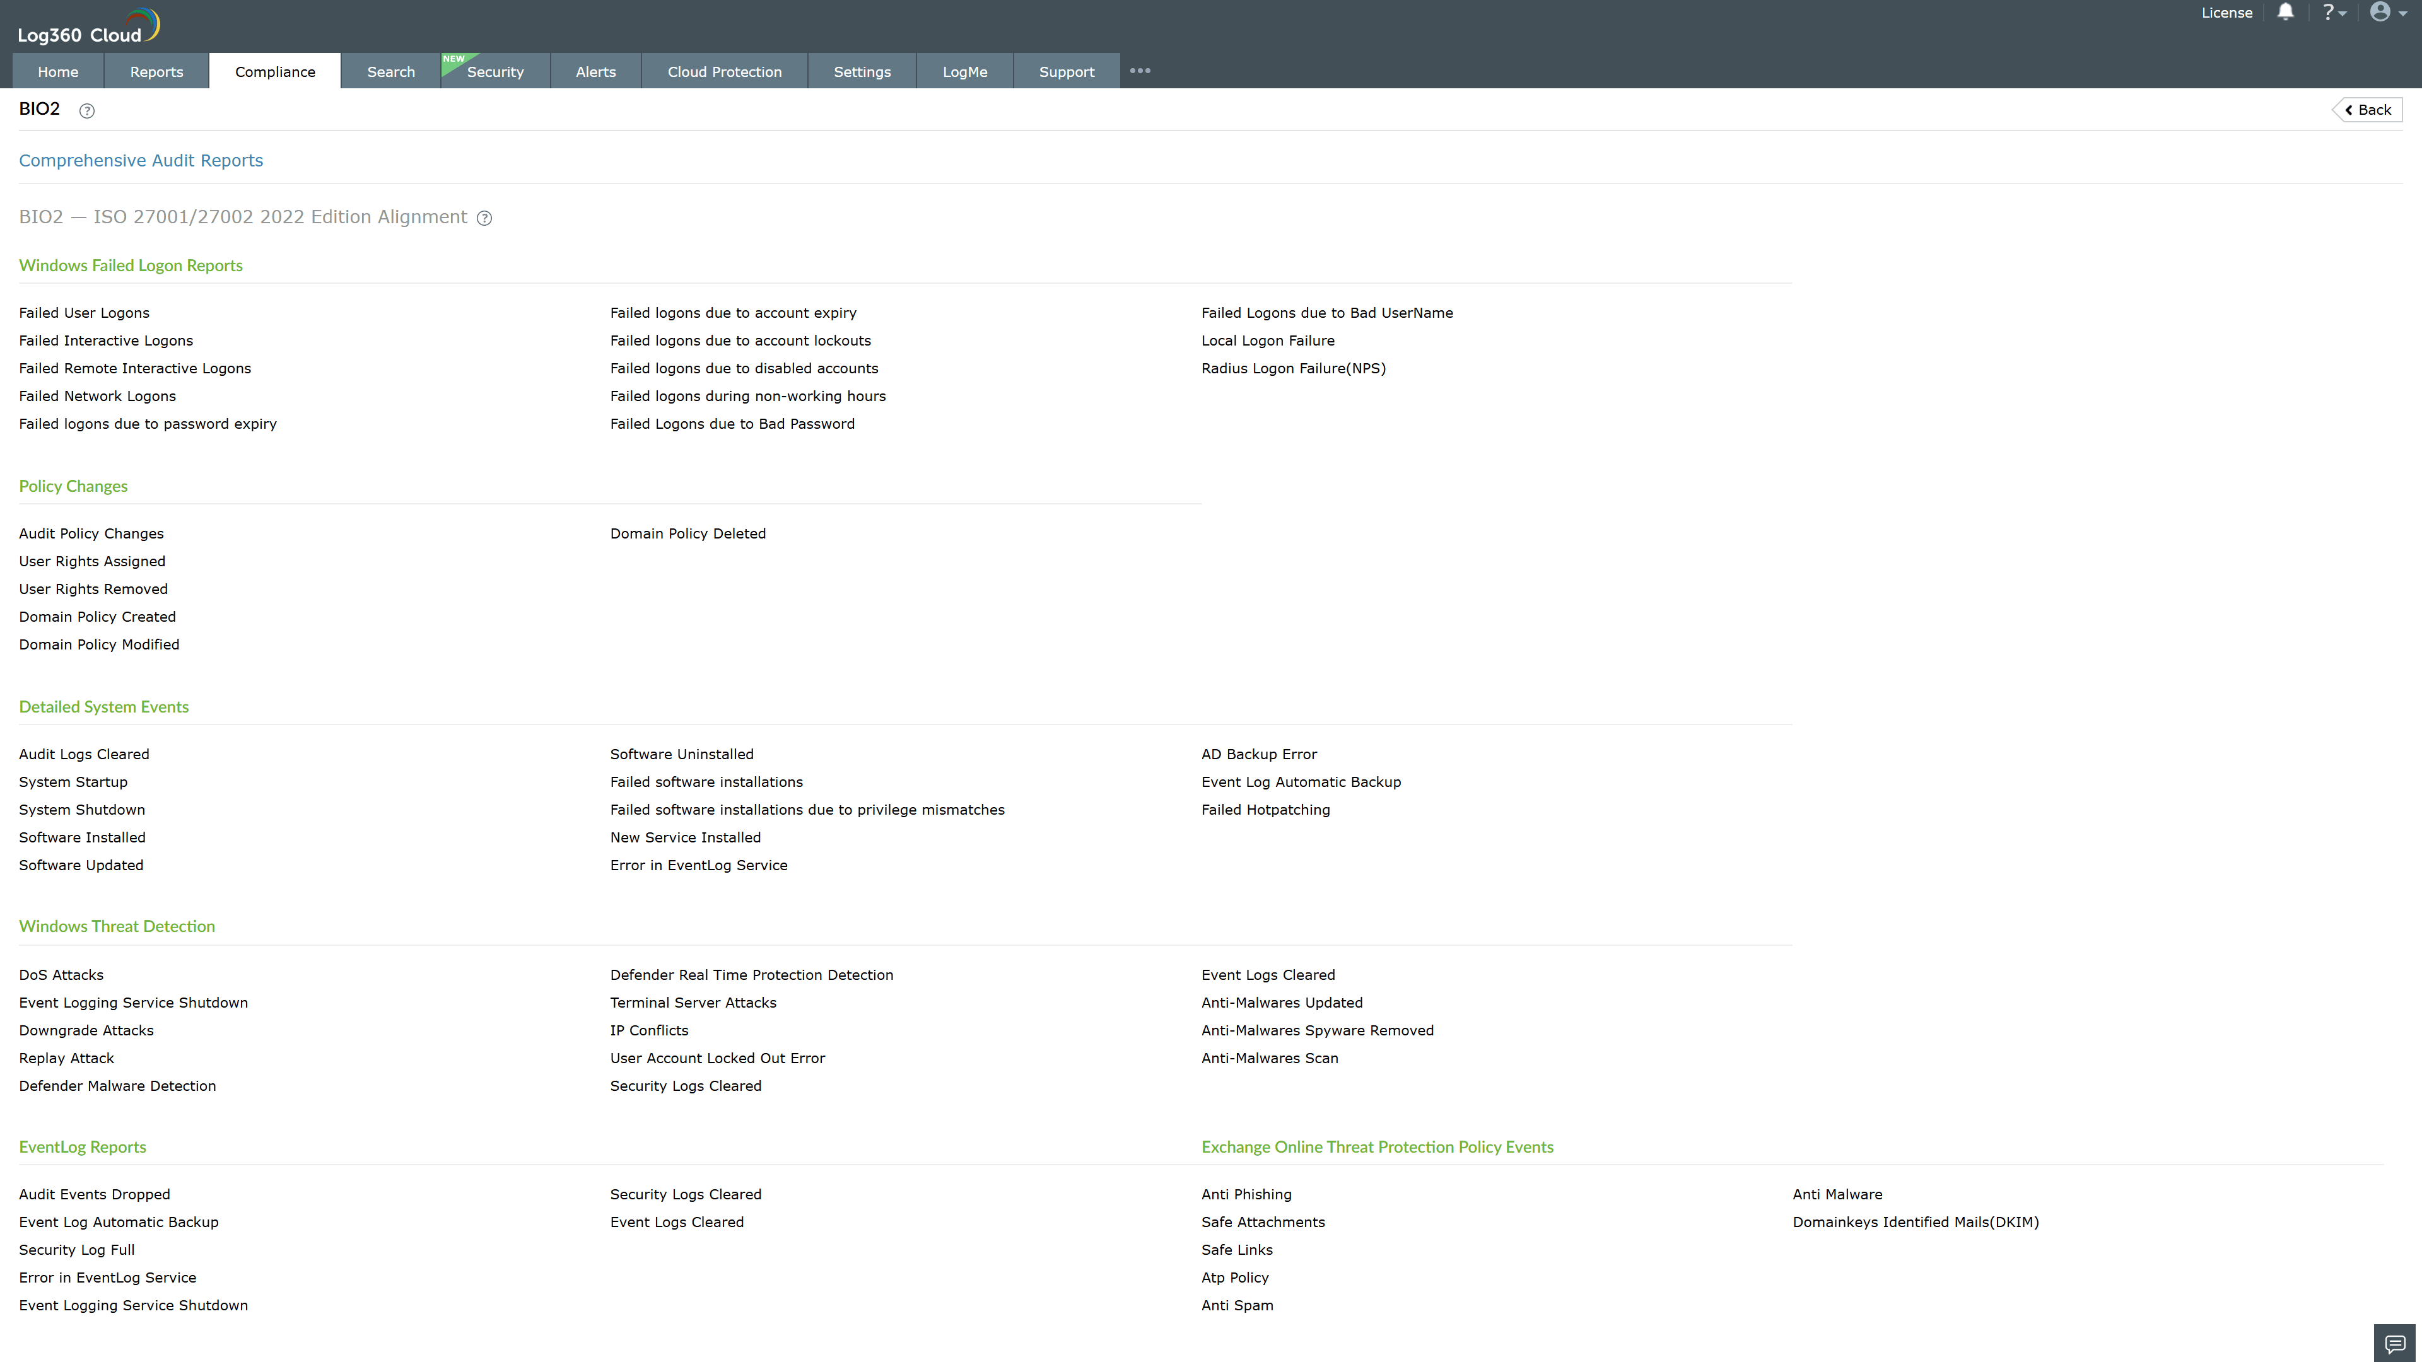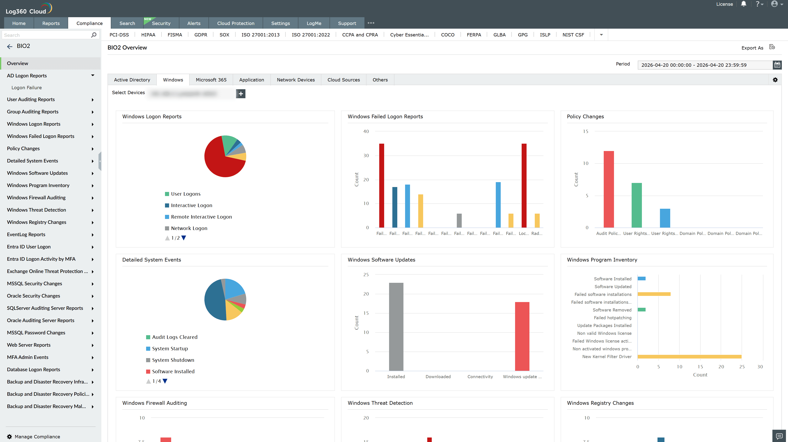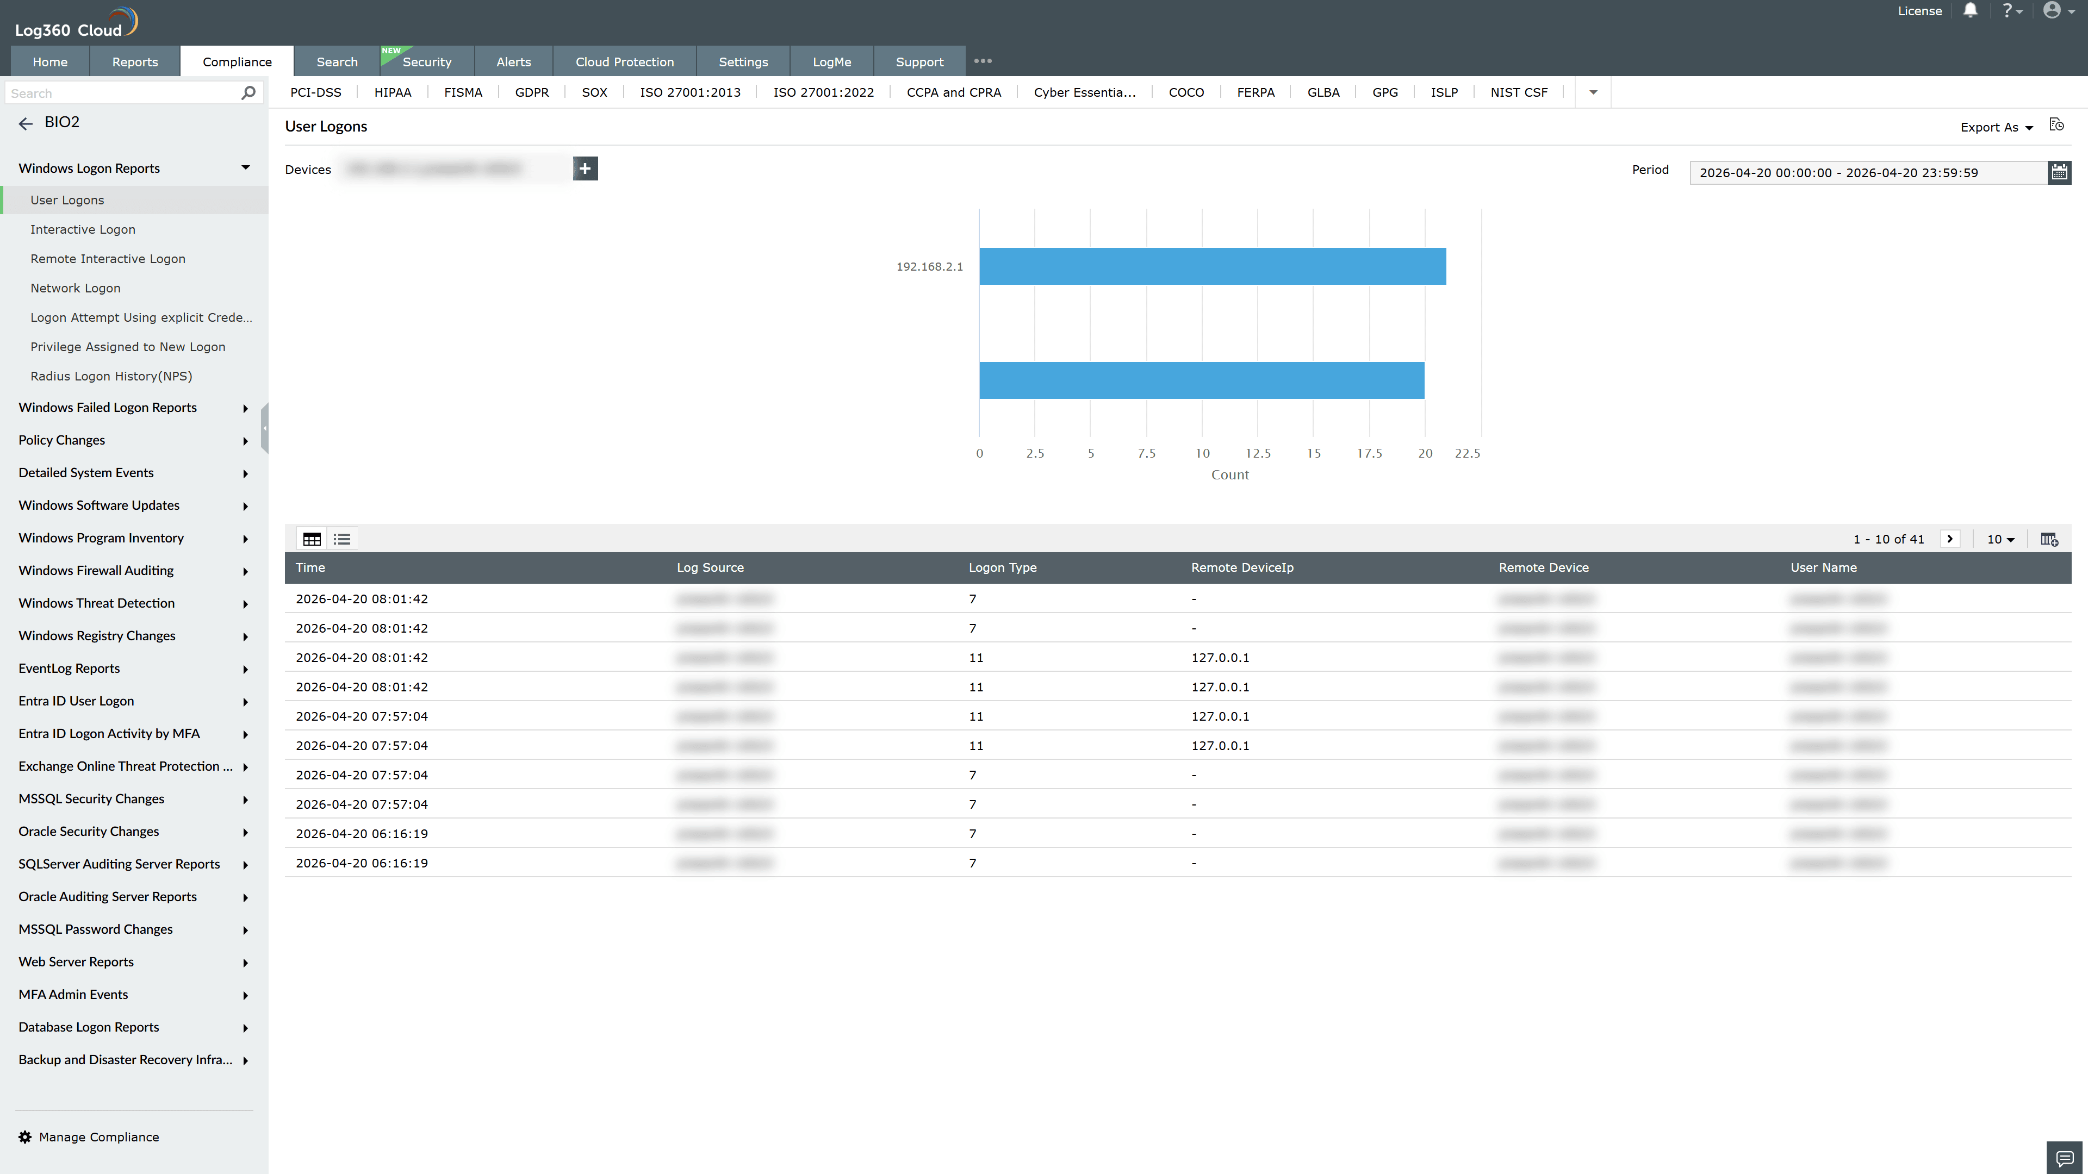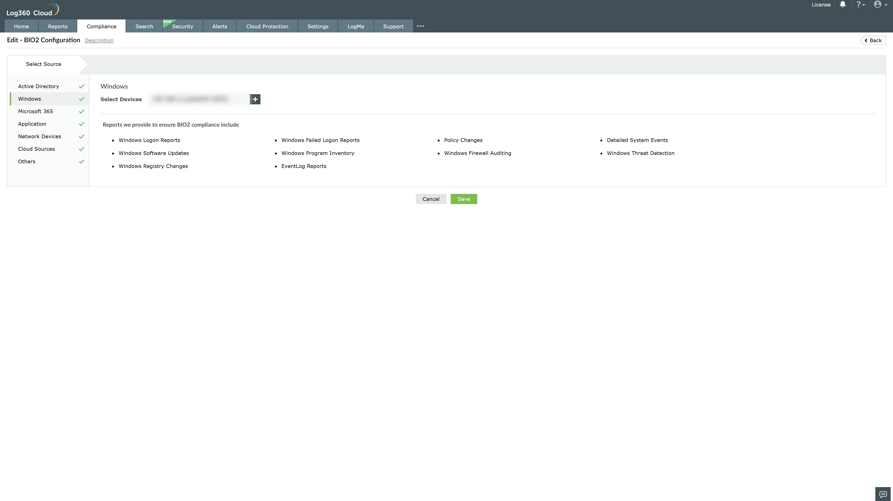

Valid Submission : Yes
Supported Editions : Free, Basic, Standard, Professional, MSSP
Help Document : https://www.manageengine.com/log-management/help/integrations/compliance-extensions.html
Help Video : Not provided
Tags : Log360, Compliance, Privacy monitoring, Data privacy, Regulatory compliance
Supported DCs : US, IN, JP, CA, AU, UK and EU
Privacy Policy:
Terms of Service:
Release Notes:
Predefined reports for the BIO2 Compliance.

